**TABELA FUNCIONÁRIO – FAIXA SALARIAL**

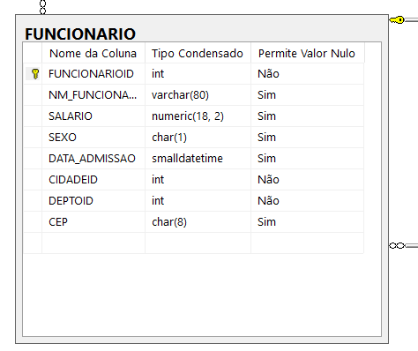

SELECT * FROM FUNCIONARIO

SELECT * FROM FUNCIONARIO WHERE SEXO = 'F'

SELECT COUNT(*) FROM FUNCIONARIO WHERE SEXO = 'F'

SELECT COUNT(*) FROM FUNCIONARIO WHERE SEXO = 'M'

SELECT COUNT(*) FROM FUNCIONARIO WHERE SEXO = 'F' AND SALARIO >=1 AND SALARIO <= 3000

SELECT COUNT(*) FROM FUNCIONARIO WHERE SEXO = 'M' AND SALARIO >=1 AND SALARIO <= 3000

SELECT COUNT(*) FROM FUNCIONARIO WHERE SEXO = 'F' AND SALARIO >=3001 AND SALARIO <= 6000

SELECT COUNT(*) FROM FUNCIONARIO WHERE SEXO = 'M' AND SALARIO >=3001 AND SALARIO <= 6000

DECLARE @INICIO INT = 1,@FIM INT = 10

WHILE @INICIO <= @FIM

BEGIN

SELECT @INICIO

SET @INICIO=@INICIO + 1

END

DECLARE @INICIO INT = 1,@FINAL INT = 3000,@FIM INT = 30000

WHILE @INICIO <= @FIM

BEGIN

SELECT @INICIO,@FINAL

SET @INICIO=@INICIO + 3000

SET @FINAL=@FINAL + 3000

END

DECLARE @INICIO INT = 1,@FINAL INT = 3000,@FIM INT = 30000

WHILE @INICIO <= @FIM

BEGIN

SELECT COUNT(*) FROM FUNCIONARIO WHERE SEXO = 'F' AND SALARIO >=@INICIO AND SALARIO <= @FINAL

SELECT COUNT(*) FROM FUNCIONARIO WHERE SEXO = 'M' AND SALARIO >=@INICIO AND SALARIO <= @FINAL

SET @INICIO=@INICIO + 3000

SET @FINAL=@FINAL + 3000

END

DECLARE @INICIO INT = 1,@FINAL INT = 3000,@FIM INT = 30000,@QT_F INT,@QT_M INT

WHILE @INICIO <= @FIM

BEGIN

SELECT @QT_F=COUNT(*) FROM FUNCIONARIO WHERE SEXO = 'F' AND SALARIO >=@INICIO AND SALARIO <= @FINAL

SELECT @QT_M=COUNT(*) FROM FUNCIONARIO WHERE SEXO = 'M' AND SALARIO >=@INICIO AND SALARIO <= @FINAL

SELECT @INICIO AS 'INÍCIO',@FINAL AS 'FIM',@QT_F AS 'MULHERES',@QT_M AS 'HOMENS'

SET @INICIO=@INICIO + 3000

SET @FINAL=@FINAL + 3000

END

--PROCEDURE

CREATE PROCEDURE SP_FS

AS

DECLARE @INICIO INT = 1,@FINAL INT = 3000,@FIM INT = 30000,@QT_F INT,@QT_M INT

WHILE @INICIO <= @FIM

BEGIN

SELECT @QT_F=COUNT(*) FROM FUNCIONARIO WHERE SEXO = 'F' AND SALARIO >=@INICIO AND SALARIO <= @FINAL

SELECT @QT_M=COUNT(*) FROM FUNCIONARIO WHERE SEXO = 'M' AND SALARIO >=@INICIO AND SALARIO <= @FINAL

SELECT @INICIO AS 'INÍCIO',@FINAL AS 'FIM',@QT_F AS 'MULHERES',@QT_M AS 'HOMENS'

SET @INICIO=@INICIO + 3000

SET @FINAL=@FINAL + 3000

END

EXECUTE SP_FS

--OLAP E OLTP

https://www.techtem.com.br/diferencas-entre-oltp-e-olap/